Report on the Republic Day Celebrations – 2025

Name of the event: - Republic Day
Date of the event: - 26Th January 2025
Venue: - KMES premises
Time: - 8.30 am to 12.00 pm

Introduction
The republic day celebrations were graced by Justice L. Narasimha Reddy, (Chancellor, North Eastern Hill University, Meghalaya, Former Chief Justice, Patna High Court and President, KMES). Members of the management Dr A. V. Subrahmanyum (Secretarty), Sri B. Sridhar Reddy (Joint Secretary), Sri L. Prabhakar Reddy (Treasurer) and Smt Vani Akkepalli (Principal KMCL).
Event Highlights
Prize Distribution: - The price distribution was graced by Justice L. Narasimha Reddy, (Chancellor, North Eastern Hill University, Meghalaya, Former Chief Justice, Patna High Court and President, KMES). Members of the management Dr A. V. Subrahmanyum (Secretarty), Sri B. Sridhar Reddy (Joint Secretary), Sri L. Prabhakar Reddy (Treasurer) and Smt Vani Akkepalli (Principal KMCL). The prize winners for the group sports events and various other activities conducted by the various clubs during the period November - January are as below
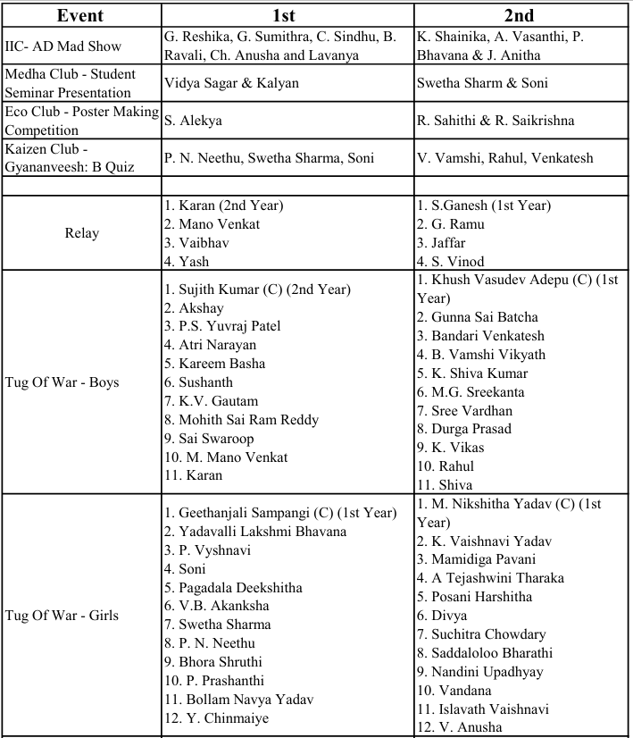
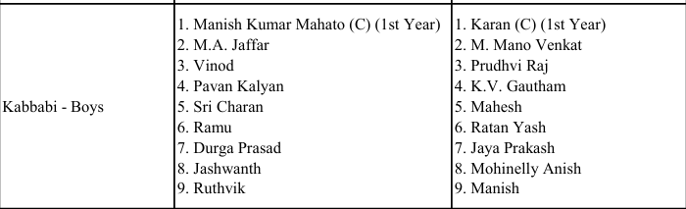

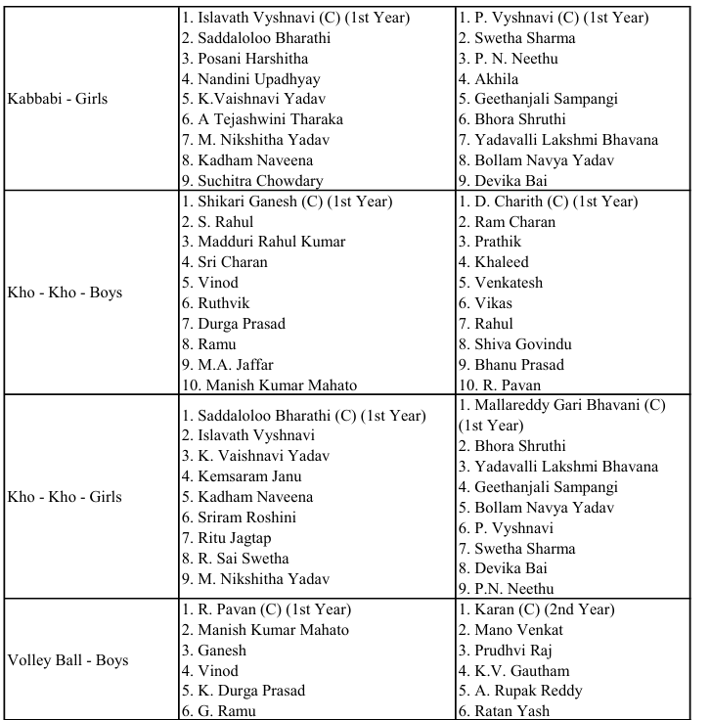
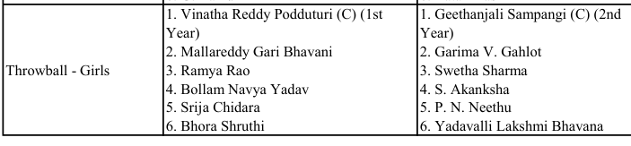

Glimpses of the event
